Get to Know: Studios

Studios Inter-Op Training

**Table of Contents**

***Supporting Information 3***

**Introduction 3**

Tools Used 3

Base Topology 3

**Example Files and Script 5**

Repository 5

Tagman Script 5

**ATD Environment 6**

Creating an ATD 6

Accessing the ATD 7

Sanitizing the ATD 8

Testing a Deployment 9

**Using Tags with the Tagman Script 10**

Adding Tags 10

Deleting Tags 10

**Onboarding Devices 11**

**Importing Studios and Inputs 12**

Enable Import of Inputs 12

Import a Studio 12

Import Studio Inputs 13

**Configuring and Submitting Studios 14**

Creating Workspaces 14

Assigning Tags 15

Submitting Workspaces 16

Approving and Executing Change Control Operations 18

Using the Campus Interfaces Studio 18

***Examples 21***

**Example One: Campus Network to ISP 22**

**Example Two: Campus to Campus EVPN 25**

**Example Three: Campus iBGP Underlay 29**

**Example Four: DC Gateway Router 33**

**Example Five: BGP DC Interconnect 35**

**Example Six: OSPF on DC Border Leaf 37**

**Example Seven: DC Border Leaf OSPF per VRF 39**

**Example Eight: eBGP Routed Enterprise 41**

**Example Nine: Campus Switch Stacking 43**

**Example Ten: EVPN eTree 45**

# Supporting Information

This section contains information to support you in completing the examples. It provides an explanation of the tools used and the necessary workflows you will complete.

The examples reference the information given here, so you can complete the examples without reading through the supporting information.

## Introduction

This document contains several use case examples for understanding how to leverage Studios to meet current customer needs. Each example uses multiple studios to deploy complex networks, and the configuration for each deployment is provided. Once deployed, the example networks can be tested to demonstrate functionality.

### Tools Used

The examples and their configuration are provided through GitHub. You will be able to import each studios configuration and upload tags using a script, tagman.py, provided in the repository. This means that minimal time will be required to configure the studios.

You’ll use an Arista Advanced Routing ATD for these examples, which provides a CloudVision environment.

### Base Topology

Each example uses devices from the below topology, which you should familiarise yourself with:



Each example has its own topology based on this, and which is provided in the instructions for the examples.

## Example Files and Script

The examples are contained in a GitHub repository and contain all of the configuration and the supporting script to successfully complete each example.

### Repository

The repository is accessible here:

<https://github.com/arista-netdevops-community/CloudVisionPortal-Examples>

The examples are contained in the following path:

CloudVisionPortal-Examples/CloudVision_Studios/InterOp_Examples_for_Studios/

The Studio versions to be used are in the Studios_to_Use directory.

Tags Files to import are in the Tags directory.

Each Ex. X Example directory contains the inputs for each studio used in that example.



### Tagman Script

Within the same path as above, you’ll find the tagman.py script, which is used to manage the tags required for each example. You’ll run this script to add or delete the tags for the examples; each example’s folder contains a .txt file, which is composed of that example’s tags.

## ATD Environment

The ATD (Arista Test Drive) is the environment used to configure and deploy these examples. With it, you’ll be able to import the necessary tags and configuration for each example and sanitize the environment when finished.

The ATD has two states: Running and Shut Down. Typically, an ATD runs for 8 hours and then shuts down. You’ll need to start the ATD once it has shut down, and it can take 10 minutes for CloudVision to restart.

You can sanitize your ATD environment using the tagman script.

### Creating an ATD

You’ll deploy a new ATD when you want a new environment to configure and deploy these examples inside. It is not necessary to create a new environment for each example; you can sanitize the environment when finished.

1. Visit <https://testdrive.arista.com/>
2. Login

**Note**: You may need to request access to this service if you are unable to login

1. You’ll be brought to the Administration screen, where you should configure a new ATD in the following way:



1. Click **Submit** and the new ATD will be deployed

You’ll receive an email with the access tokens, and can now access this ATD environment

### Accessing the ATD

When an ATD has been created, you’ll receive access tokens to enter the environment and it will start automatically. Typically an ATD will run for 8 hours before shutting down, and if it has shut down you’ll need to restart it. The starting process can take 10 minutes.

1. Access the ATD via its access token
2. You’ll then be brought to the ATD’s management page, where you can start, shut down or access the topology



If the status reads **Your topology is currently: Shut down** click **Start**

1. Click **Click Here to Access Topology** and you’ll be brought to the configuration screen



You may need to scroll down to see all the relevant information.

1. This shows the time remaining on the ATD before it shuts down and needs to be restarted
2. This shows the status of CloudVision. If it does not state “currently UP”, you will need to wait until it does so – CloudVision is still loading
3. These are your login credentials for accessing this ATD’s CloudVision instance
4. Click here to access the instance’s version of CloudVision
5. Click on **CVP** to access CloudVision and login using the lab credentials

### Sanitizing the ATD

You’ll sanitize and ATD using the Tagman script to remove the tags applied for the example, and you’ll also remove any tag assignments made during the studio.

1. Run the tagman script with the delete command
2. Unassign any tags that have been assigned to a configured studio and delete the top-level inputs in each configured studio



1. Confirm that the tags have been deleted by entering Tags and selecting **All Devices**

The ATD is now sanitised and you can begin importing tags for a new example, and configuring the studios required for that example.

### Testing a Deployment

On the configuration screen, you will be able to access a CLI for each device in the topology.

Click on a device in the topology to access its CLI. Use the lab credentials of your ATD to log into the device’s CLI.



## Using Tags with the Tagman Script

A python script, tagman.py, is provided with the repository. This can be used to add and delete the required tags for each example quickly.

A specific file, tagsfile.txt, is provided with each example that can be exported to the ATD using tagman.py.

The syntax of the command to run the script is:

|  |
| --- |
| $ python tagman.py -u [ATD username] -p [ATD password] -c [ATD DNS without preceding “https://” and trailing “/”] -f [the example tagsfile.text] -a import |

**Note**: Any open workspace in the ATD will be unaware of any changes to tags you make with tagman.py. You will need to create a new workspace after running any of its commands.

You can check the status of the tags on the ATD in the Tags section of Provisioning.

### Adding Tags

To add tags for a given example, you’ll append -o add to the command, like in the example below that adds Example 1 tags:

|  |
| --- |
| $ python tagman.py -u arista -p arista4f2k -c unf-1-d2c4af25.topo.testdrive.arista.com -f tagsfile-example1.txt -a import -o add |

### Deleting Tags

To delete tags, you’ll append -o delete to the command, like in the below example that deletes the Example 1 tags:

|  |
| --- |
| $ python tagman.py -u arista -p arista4f2k -c unf-1-d2c4af25.topo.testdrive.arista.com -f tagsfile-example1.txt -a import -o delete |

## Onboarding Devices

Devices need to be onboarded to the Studios environment in order for configuration to be pushed to them. If you do not onboard the devices, any configuration created and subsequently executed in Change Control will not be applied to the devices.

1. Create a Workspace and enter Inventory and Topology
2. Click the **Updates** tab and click **Add All New Updates**



1. Click **Review Workspace**
2. Submit the workspace

The devices are now available to be provisioned by Studios and configuration can be pushed to them.

## Importing Studios and Inputs

The studios and inputs required to complete the examples are available for import in the CloudVision_Studios folder of the cloned repository.

### Enable Import of Inputs

1. Visit General Settings in Settings
2. Press ctrl + A to reveal the alpha settings



1. Scroll to the bottom of Features and enable Studios Alpha Features



You’ll now be able to import Studio inputs.

### Import a Studio

1. Visit Studios
2. Create a workspace
3. Click **Import**



1. In the Import Modal, navigate to the CloudVision_Studios folder in the cloned repository
2. Select the relevant studio or inputs. Each studio is specified within each example.
3. Click **Upload**

The Studio will now be available to configure.

### Import Studio Inputs

1. You need to access the studio that you want to import the inputs into
2. Within the studio, click the **ellipsis** beside Edit



1. Select **Import** under Inputs and navigate to the inputs file in your folder
2. Click **Upload**

Once you have done this, the studios will include the configuration.

## Configuring and Submitting Studios

The vast majority of the configuration required to successfully deploy these examples is imported. You will, however, need to do some basic configuration and complete the essential workflows of Studios.

More information on using Studios can be found [here](https://docs.google.com/document/d/1Hsib-Ox-ycp1iTPiuzKY7Om8ve7Ej_d1FOWeAWhAju4/edit).

### Creating Workspaces

A workspace is an instance used to record and build configuration changes you make in Studios. You’ll need to create a workspace to import studios and inputs, to onboard devices, and to configure studios. You can complete these examples with one workspace or you can use multiple workspaces.

1. Click **Create Workspace**, which will bring up the Create New Workspacemodal. You can do this within Studios:



1. Give your new workspace a name and a description, and then click **Create**



The Workplace you’ve created can now be used to manage the configuration of one or more studios. It will be available for use in the workspace dropdown menu.

### Assigning Tags

Tags identify the devices a studio will configure and are used in inputs. You’ll need to assign tags to any studios that you configure so that configuration can be pushed to those devices.

Within each studio, with the exception of Inventory and Topology, there is a Device Selection option.



You’ll use Device Selection to specify the devices that any given studio’s configuration affects. All of the tagged devices you select must already have been onboarded for use in Studios with the [Inventory and Topology Studio](https://docs.google.com/document/d/1Hsib-Ox-ycp1iTPiuzKY7Om8ve7Ej_d1FOWeAWhAju4/edit#heading=h.9swfxqanlo73). In order to assign devices, click **Set Tag Query** and then enter a device tag query.



You can edit these tagged devices at any point with a workspace by clicking the pencil icon to the right of the last tag.

You can use tags to apply an entire studio to a selected group of devices. For example, you may want the configuration of a studio to relate only to devices in a particular data center. All devices in that data center can be tagged under a label, and you can assign that studio to that tag label.

### Submitting Workspaces

You’ll submit workspaces to Change Control in order to push a workspace’s configuration to devices. The workspace’s configuration is then approved and executed in Change Control.

1. Click the **Review Workspace** button in the header



1. The workspace will be automatically built for submission, which includes input validation, compiling the configuration, and the validation of the configuration. On the Build screen, you’ll be able to [review the proposed configuration changes](https://docs.google.com/document/d/1Hsib-Ox-ycp1iTPiuzKY7Om8ve7Ej_d1FOWeAWhAju4/edit#heading=h.1x0gk37)

**Note**:The workspace is automatically built only for the first time that you click ReviewWorkspace. Any subsequent changes made after that will require that you re-build the workspace by clicking **Start Build**.

1. Once satisfied, you can click **Submit Workspace**



1. You’ll be presented with a modal that will bring you to Change Control



A change control operation will now be created and you can approve and execute this in Change Control.

**Note**:Not all workspace submissions will create a change control operation. The View Change Control button will be disabled when no configuration changes have been created, but any other changes will come into effect.

### Approving and Executing Change Control Operations

Once a workspaces has been submitted, it creates a change control operation that must be approved and executed. When executed, the configuration submitted by the workspace is pushed to the devices.

1. Click **Review and Approve**



1. You’ll now see a modal that displays a summary of the configuration changes, which also allows you to add a custom note to the change control



1. Toggle on **Execute Immediately** and click **Approve and Execute**

The change control operation will now begin to execute and its configuration will be pushed to devices.

# **Examples**

Ten examples are provided showing diverse network deployments using multiple studios. These examples can be completed quickly and effectively, enabling you to understand how studios functions on a basic level and how it meets today’s networking demands.

The supporting information given above is referenced within the examples, and it is not necessary to begin with any specific example.

**Note**: You must set up an ATD in order to run and deploy these examples.

## Example One: Campus Network to ISP

**Overview**

In this example, you’ll deploy a campus network that is connected to an ISP. Between the Campus and the ISP is an Edge Router (ER) acting as a network core/WAN router that runs OSPF to the Campus Splines and eBGP to the ISP. The BGP policy on the WAN router sends an Aggregate route to the ISP and sends only a default route to the Campus.



**Topology**



**Features**

* MLAG and virtual router address
* Routed interface and eBGP to external peer
* OSPF on Campus Splines
* OSPF to BGP redistribution
* Prefix list and BGP policy towards ISP
* OSPF default information originate

**Import**

Enterprise Routing

Campus Fabric

**Configure**

1. Sanitize the ATD, if necessary
2. Run the tagman.py script for tagsfile-example1.txt
3. Import the Enterprise Routing and Campus Fabric studios inputs
4. Complete the tag assignment for each studio

|  |  |  |
| --- | --- | --- |
| **Studio** | **Tag Label** | **Tag Value** |
| Enterprise Routing | Network | Ex1-CoreNet-eos1-eos11-eos13 |
| ISP-eos7-eos10-eos19 |
| Campus Fabric | Campus | Campus-eos11-eos12-eos13 |

**Deploy**

You’ll now push the configuration you’ve imported to the devices:

1. Review and submit the workspace to Change Control
2. Approve and Execute the change control operation

**Test the Deployment**

Use the ATD’s configuration screen to access a CLI for the below devices:

* From eos12 ping eos10 on 10.10.10.10

## Example Two: Campus to Campus EVPN

**Overview**

In this example, you’ll deploy a second Campus and stretch a VLAN between the Campus using EVPN and VXLAN. The internal routing protocol is ISIS and the EVPN control is using iBGP and a separate Route Reflector (perhaps this is a VM in the real world). Both users are on the same VLAN and the user on the left should be able to ping the user on the right. The ISP should still be reachable.



**Topology**



**Features**

* EVPN control plane
* MAC VRF on Campus Splines
* Trunk port and Routed port profiles

**Import**

Enterprise Routing

Campus Fabric

EVPN Services

Campus Interfaces

**Configure**

1. Sanitize the ATD, if necessary
2. Run the tagman.py script for tagsfile-example2.txt
3. Import the Enterprise Routing, EVPN Services, Campus Interfaces, and Campus Fabric inputs
4. Set the tag assignment for each studio

|  |  |  |
| --- | --- | --- |
| **Studio** | **Tag Label** | **Tag Value** |
| Enterprise Routing | Network | Ex2-CoreNet-eos1-eos2-eos5-eos11-eos13-eos17 |
| ISP-eos7-eos10-eos19 |
| Campus-EndDevice-eos20 |
| Campus Fabric | Campus | Campus-eos11-eos12-eos13 |
| Campus-eos2-eos3-eos4-eos5 |
| EVPN Services | device | eos2 |
| eos5 |
| eos11 |
| eos13 |
| Campus Interfaces | device | eos3 |
| eos9 |
| eos4 |
| eos20 |

**Deploy**

You’ll now push the configuration you’ve imported to the devices:

1. Review and submit the workspace to Change Control
2. Approve and Execute the change control operation

**Test**

Use the ATD’s configuration screen to access a CLI for the below devices:

* From Campus switch eos12 ping DC end device eos9 15.15.15.133 and eos20 15.15.15.134
* From Campus switches eos12, ping to eos10 10.10.10.10 and eos19 19.19.19.19 on the ISP Network
* From Campus end devices eos9 and eos20, ping to eos10 10.10.10.10 and eos19 19.19.19.19 on the ISP Network

## Example Three: Campus iBGP Underlay

**Overview**

In this example, you’ll deploy the underlay and overlay using iBGP and the Route Reflector is collapsed into the Core Router for both the underlay and the overlay. A VLAN is stretched between 2 Campus and the user on the left should be able to ping the user on the right. The ISP should still be reachable.



**Topology**



**Features**

* Pure BGP routed Campus
* Route Reflector and Core router same device

**Import**

Campus Fabric

Enterprise Routing

EVPN Services

Campus Interfaces

**Configure**

1. Sanitize the ATD, if necessary
2. Run the tagman.py script for tagsfile-example3.txt
3. Import the Enterprise Routing, EVPN Services, Campus Interfaces and Campus Fabric inputs
4. Set the tag assignment for each studio

|  |  |  |
| --- | --- | --- |
| **Studio** | **Tag Label** | **Tag Value** |
| Enterprise Routing | Network | Ex3-CoreNet-eos1-eos2-eos5-eos11-eos13 |
| ISP-eos7-eos10-eos19 |
| Campus Fabric | Campus | Campus-eos2-eos3-eos4-eos5 |
| Campus-eos11-eos12-eos13 |
| EVPN Services | device | eos2 |
| eos5 |
| eos11 |
| eos13 |
| Campus Interfaces | device | eos3 |
| eos9 |
| eos4 |
| eos20 |

**Deploy**

You’ll now push the configuration you’ve imported to the devices:

1. Review and submit the workspace to Change Control
2. Approve and Execute the change control operation

**Test**

Use the ATD’s configuration screen to access a CLI for the below devices:

* From Campus switch eos12 ping DC end device eos9 15.15.15.133 and eos20 15.15.15.134
* From Campus switches eos12, ping to eos10 10.10.10.10 and eos19 19.19.19.19 on the ISP Network
* From Campus end devices eos9 and eos20, ping to eos10 10.10.10.10 and eos19 19.19.19.19 on the ISP Network

## Example Four: DC Gateway Router

**Overview**

In this example, you’ll deploy 2 Data Centers and connect them together with 3 Core routers running OSPF. The Edge routers in the Core are the gateways for servers using L2 EVPN in the overlay. The servers in each DC are on different IP subnets which are redistributed into OSPF in the Core. Note that one server has a routed port IP interface and the other has an SVI in the Campus Interfaces Studio. The respective servers should be able to ping each other.

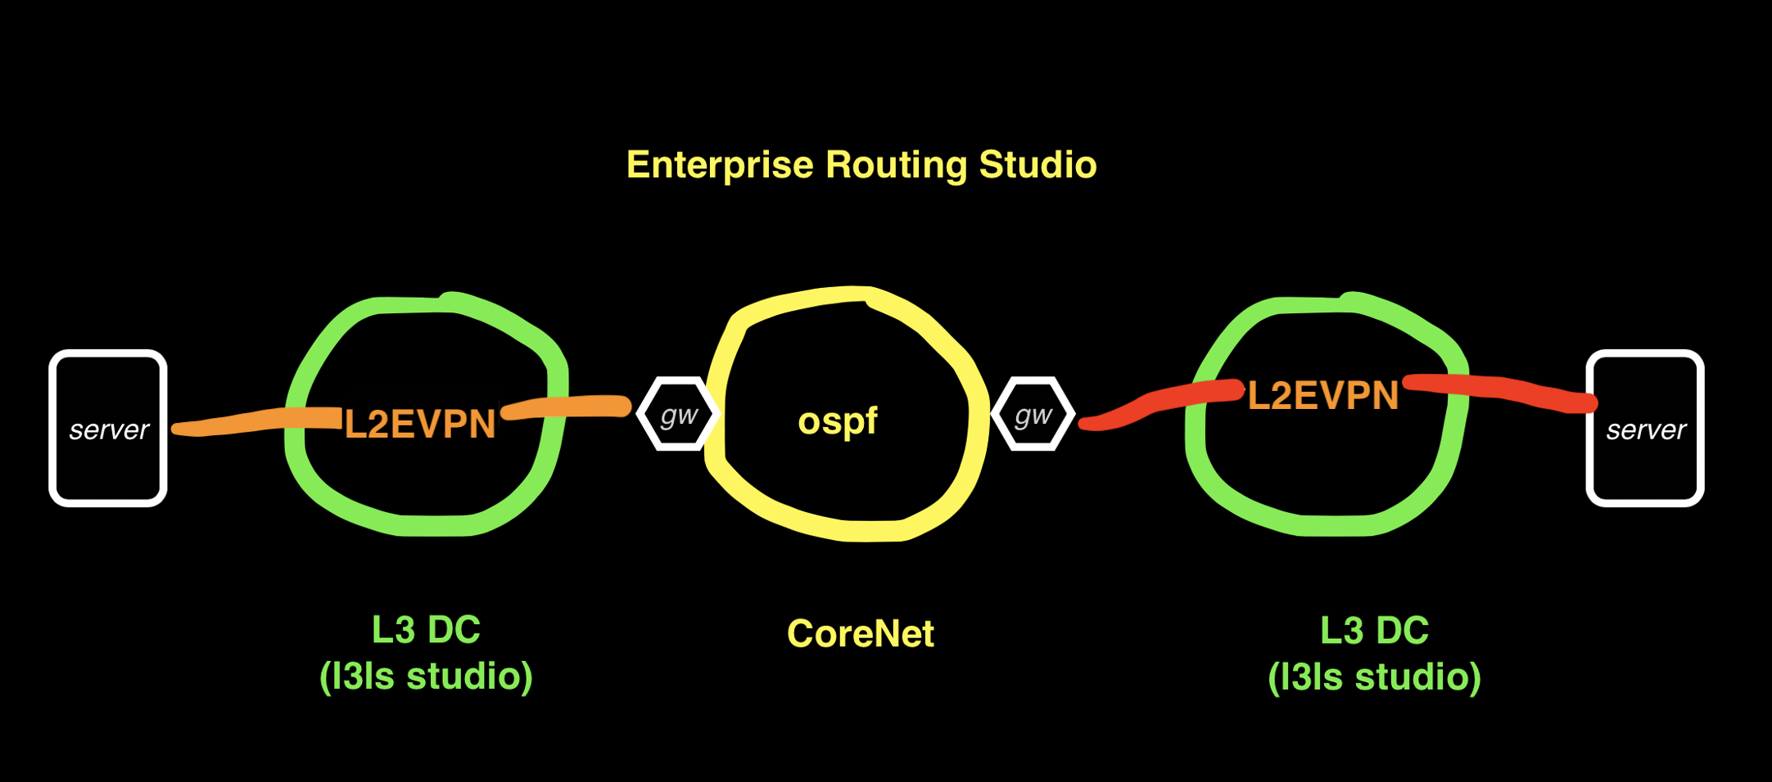

**Topology**

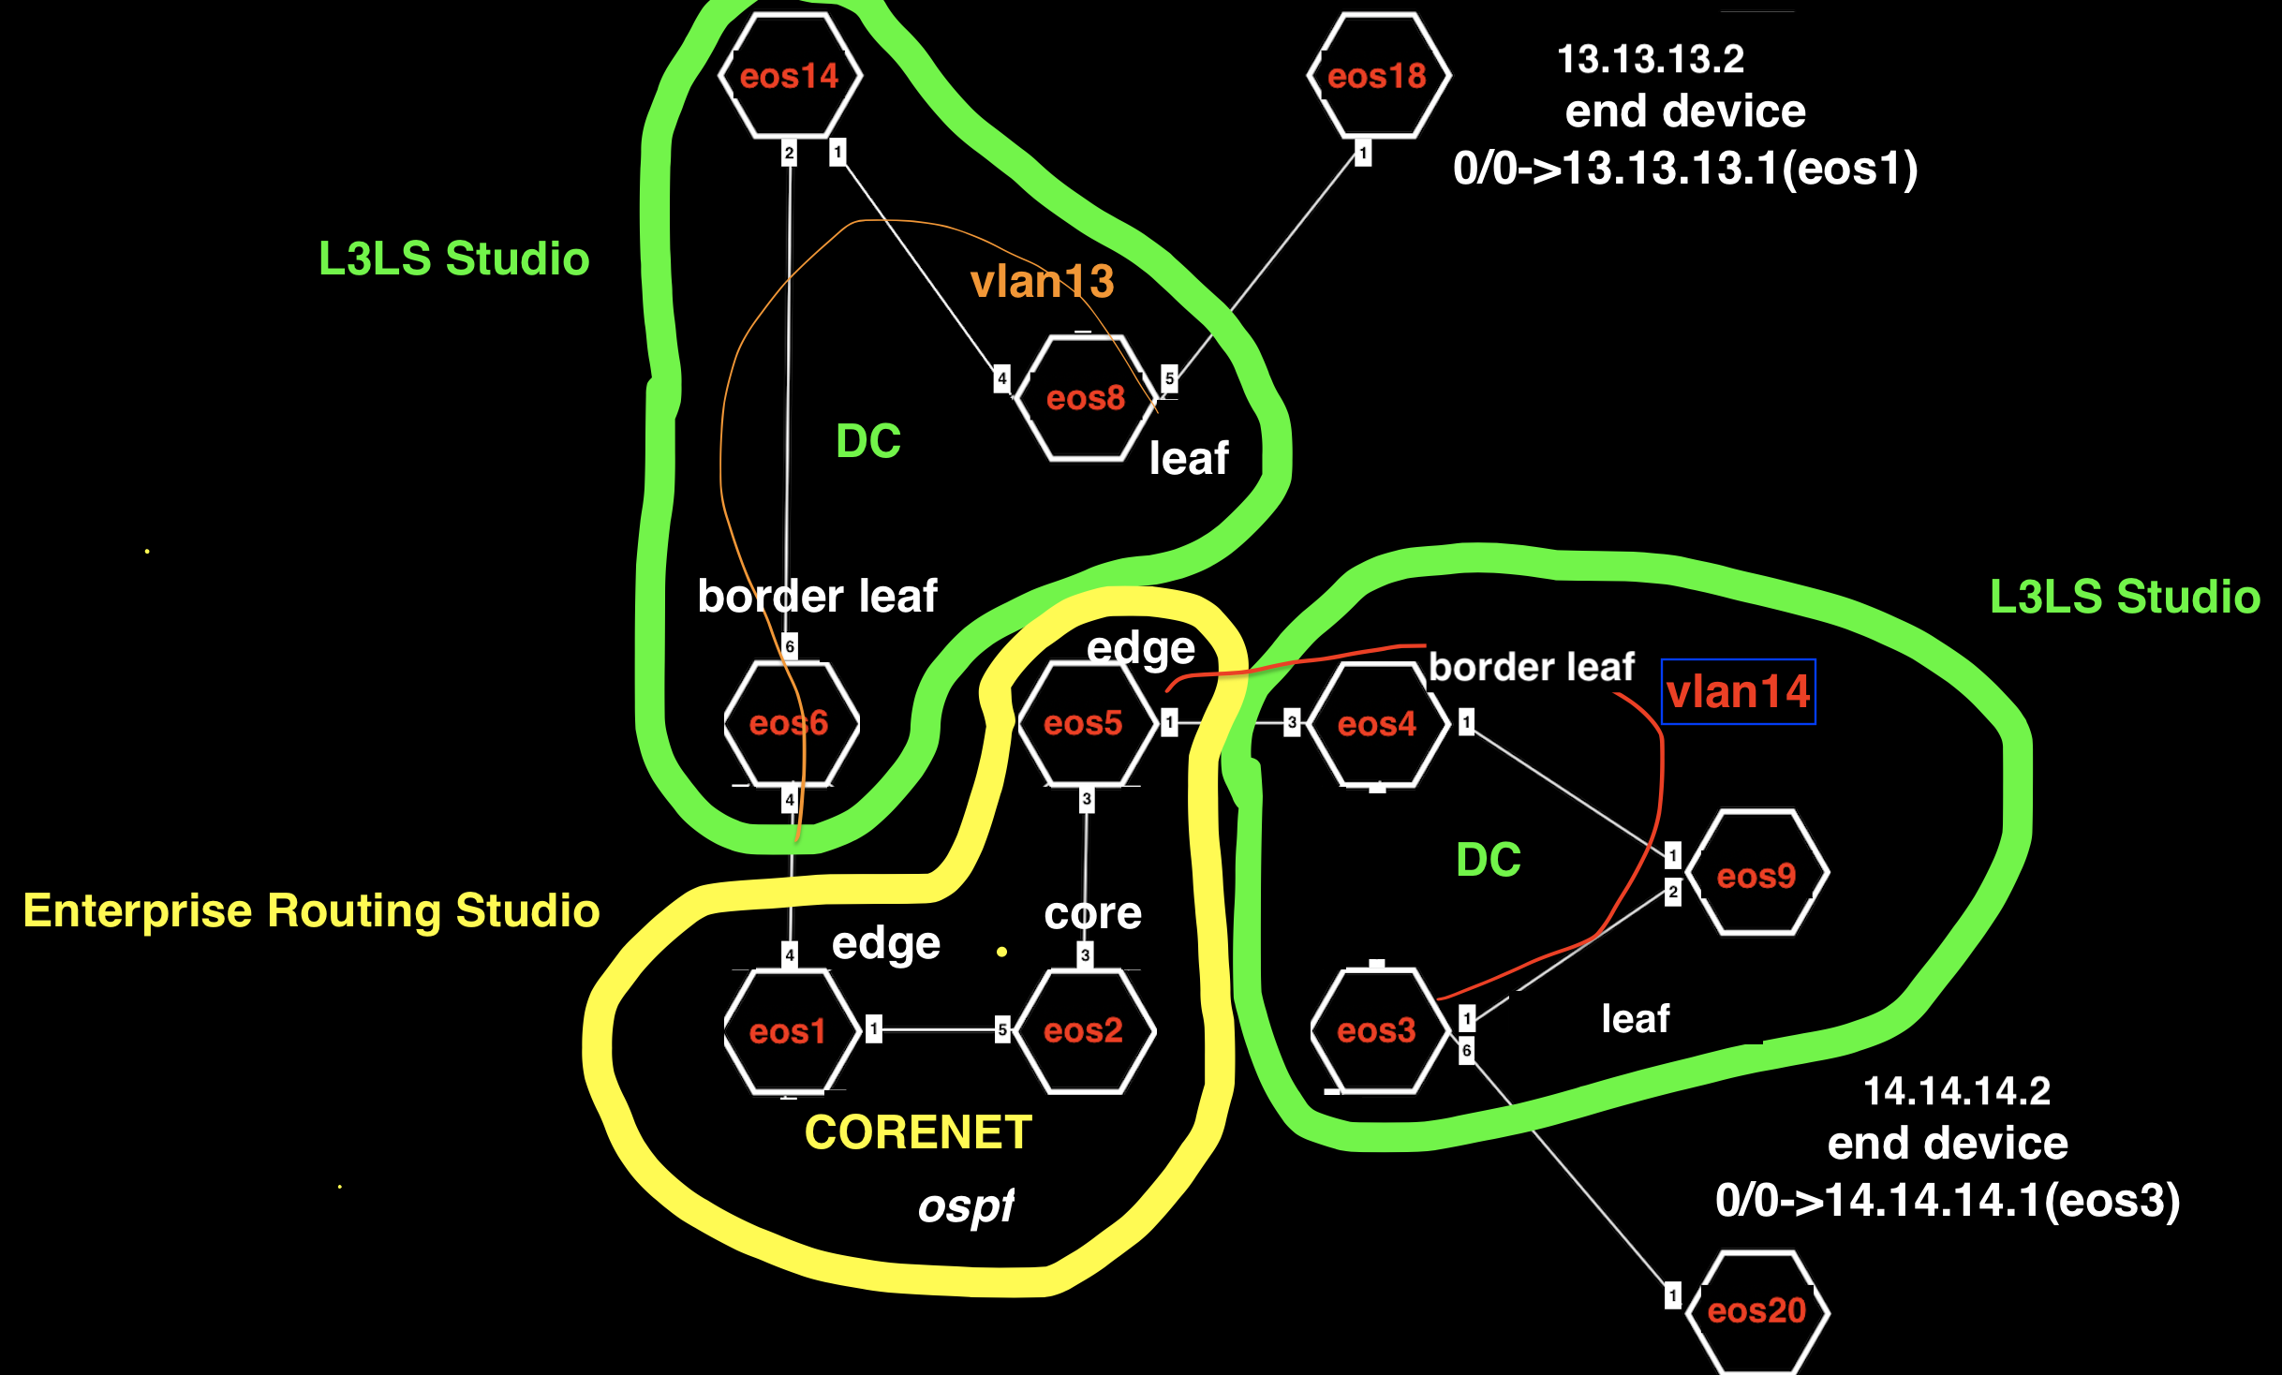

**Features**

* L2EVPN to Border Leaf in 2 DCs to Core Routers
* Mutual OSPF to BGP redistribution
* GW for servers defined on routed port sub-interface

**Import**

Enterprise Routing

L3 Leaf-Spine

EVPN Services

Campus Interfaces

**Configure**

1. Sanitize the ATD, if necessary
2. Run the tagman.py script for tagsfile-example2.txt
3. Import the Enterprise Routing, EVPN Services, Campus Interfaces, and L3 Leaf-Spine inputs
4. Set the tag assignment for each studio

|  |  |  |
| --- | --- | --- |
| **Studio** | **Tag Label** | **Tag Value** |
| Enterprise Routing | Network | Ex4-CoreNet-eos1-eos2-eos5 |
| L3 Leaf-Spine | DC | DC-eos3-eos4-eos9 |
| DC-eos6-eos8-eos14 |
| EVPN Services | device | eos3 |
| eos4 |
| eos6 |
| eos8 |
| Campus Interfaces | device | eos3 |
| eos4 |
| eos6 |
| eos8 |

**Deploy**

You’ll now push the configuration you’ve imported to the devices:

1. Review and submit the workspace to Change Control
2. Approve and Execute the change control operation

**Test**

Use the ATD’s configuration screen to access a CLI for the below devices:

* From eos18 ping to eos20 14.14.14.2

## Example Five: BGP DC Interconnect

**Overview**

In this example, you’ll deploy 2 Data Centers and use L3 EVPN in each. The DC Border Leafs have eBGP sessions to the Core Edge router and routes learned from the DCs are redistributed into OSPF. Servers in the respective DCs should be able to ping each other.



**Topology**

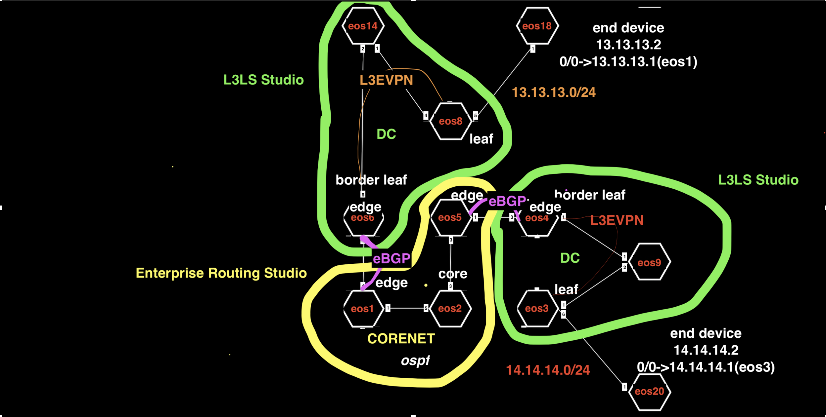

**Features**

* L3EVPN to Border Leafs in 2 DCs
* Orange side configures eBGP from EVPN Studio
* Red side configures eBGP from Enterprise Routing Studio

**Import**

L3 Leaf-Spine Fabric

Enterprise Routing

EVPN Services

Campus Interfaces

**Configure**

1. Sanitize the ATD, if necessary
2. Run the tagman.py script for tagsfile-example2.txt
3. Import the Enterprise Routing, EVPN Services, Campus Interfaces, and L3 Leaf-Spine inputs
4. Set the tag assignment for each studio

|  |  |  |
| --- | --- | --- |
| **Studio** | **Tag Label** | **Tag Value** |
| Enterprise Routing | Network | Ex5-CoreNet-eos1-eos2-eos5 |
| DC-Border-Leaf-eos4 |
| L3 Leaf-Spine | DC | DC-eos3-eos4-eos9 |
| DC-eos6-eos8-eos14 |
| EVPN Services | device | eos3 |
| eos4 |
| eos6 |
| eos8 |
| Campus Interfaces | device | eos3 |
| eos8 |
| eos18 |
| eos20 |

**Deploy**

You’ll now push the configuration you’ve imported to the devices:

1. Review and submit the workspace to Change Control
2. Approve and Execute the change control operation

**Test**

Use the ATD’s configuration screen to access a CLI for the below devices:

* From eos18 ping eos20 14.14.14.2

**Note:** You may have to clear the ARP cache on eos18, because the MAC address of its default gateway has changed from the previous example

## Example Six: OSPF on DC Border Leaf

**Overview**

In this example, you’ll deploy a L2 Data Center NOC (which is provisioned with the Campus Studio) and a L3 DC and overlay is ignored. The NOC is running OSPF on the L2DC Spine to Core routers which connect to the Border Leaf underlay. We will be redistributing the management subnet for servers into OSPF and testing traffic. The NOC server on the left should be able to ping the DC server on the right.

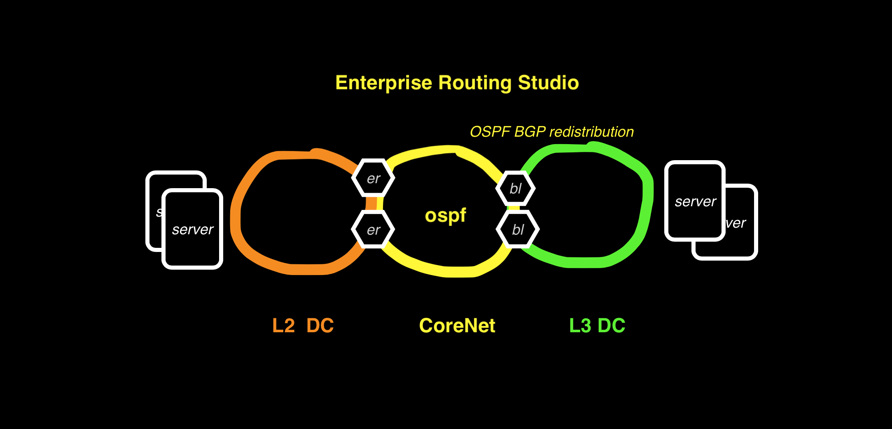

**Topology**



**Features**

* Connect network to DC underlay
* Dual Roles for Border Leafs – Edge router and Leaf
* Redundant OSPF to BGP redistribution
* Routing loop prevention
* Modifying prefix-list PL_P2P_UNDERLAY

**Import**

Enterprise Routing

Campus Fabric

L3 Leaf-Spine

Campus Interfaces

**Configure**

1. Sanitize the ATD, if necessary
2. Run the tagman.py script for tagsfile-example2.txt
3. Import the Enterprise Routing, Campus Fabric, Campus Interfaces and L3 Leaf-Spine inputs
4. Set the tag assignment for each studio

|  |  |  |
| --- | --- | --- |
| **Studio** | **Tag Label** | **Tag Value** |
| Enterprise Routing | Network | Ex6-CoreNet-eos1-eos2-eos5-eos6-eos11-eos13 |
| L3DC-End-device-eos9 |
| Campus Fabric | Campus | L2DC-eos11-eos12-eos13 |
| L3DC-End-device-eos9 |
| L3 Leaf-Spine | DC | L3DC-eos2-eos3-eos4-eos5-eos9 |
| Campus Interfaces | device | eos9 |

**Deploy**

You’ll now push the configuration you’ve imported to the devices:

1. Review and submit the workspace to Change Control
2. Approve and Execute the change control operation

**Test**

Use the ATD’s configuration screen to access a CLI for the below devices:

* From Campus switch eos12 ping DC Leaf eos9 14.14.14.2
* From DC Leaf eos9 14.14.14.2 ping Campus switch eos12

## Example Seven: DC Border Leaf OSPF per VRF

**Overview**

In this example, you’ll deploy a L2 Data Center (which is provisioned with the Campus Studio) and a L3 DC (eBGP in the underlay) but this time with an L3 EVPN overlay. The L2 DC is running OSPF on the Spine to 2 Core routers. Further we will be redistributing the BGP route for the L3 DC server from a VRF on the Border Leafs into OSPF and testing traffic. The server on the left should be able to ping the server on the right.

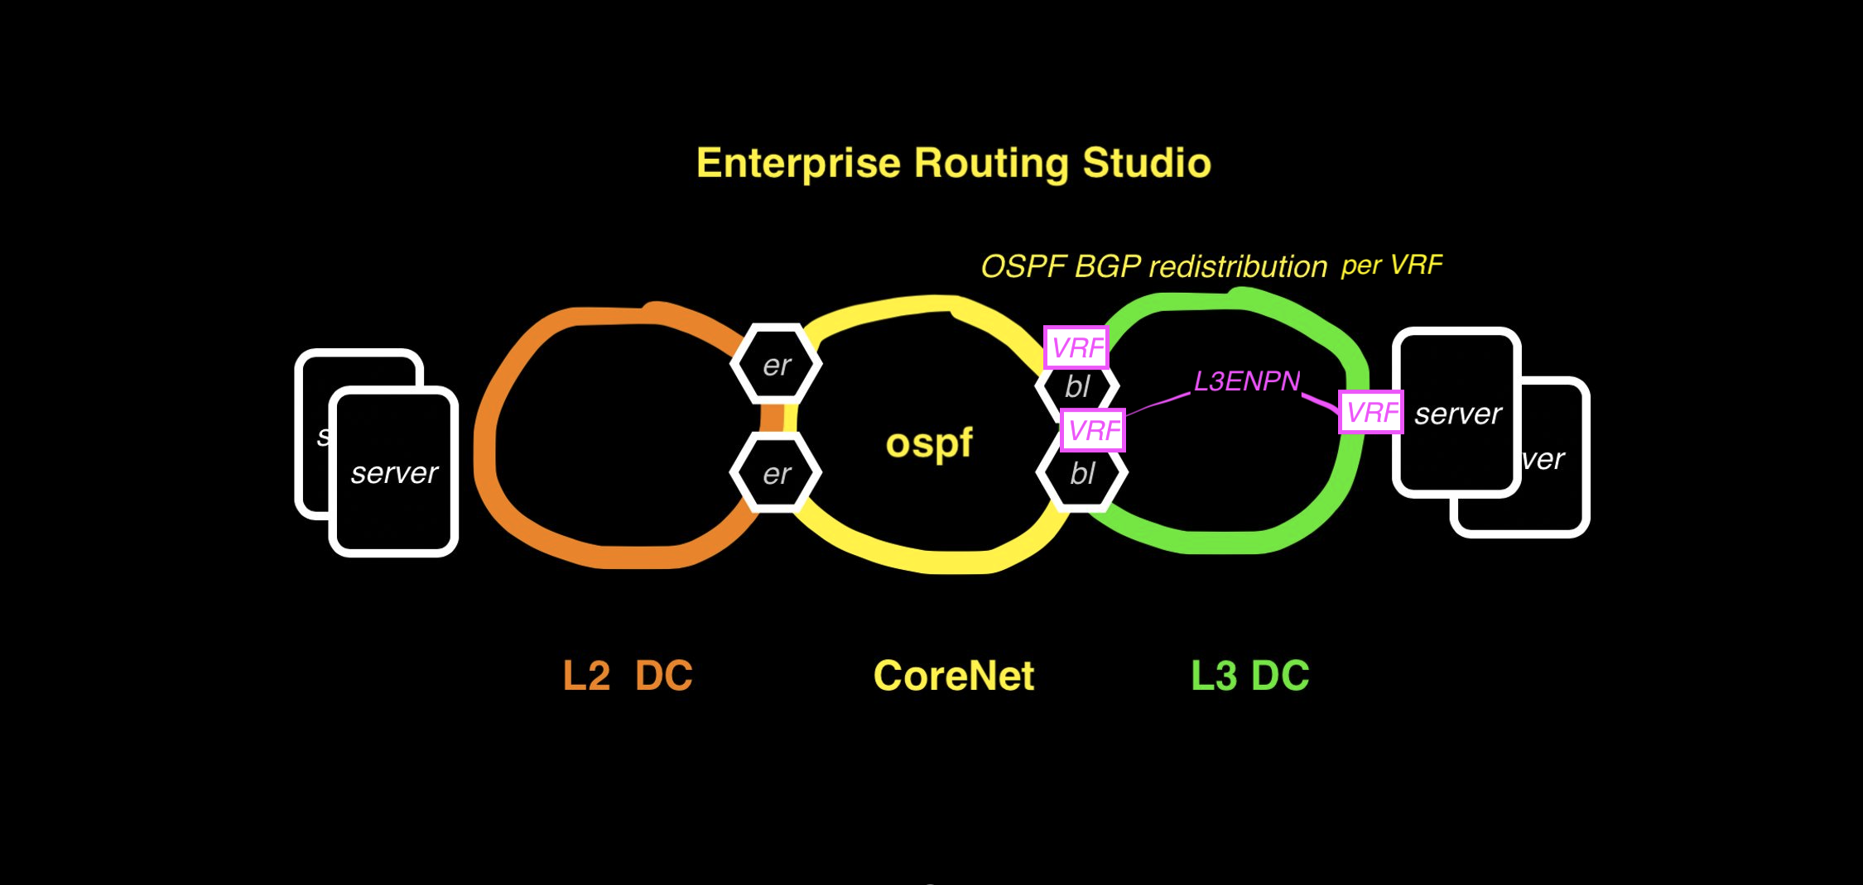

**Topology**



**Features**

* OSPF BGP redistribution in VRF on Border Leaf
* BGP to OSPF route map
* OSPF on ex Dual Roles for Border Leafs – Edge router and Leaf
* ternal sub-interface
* Same BGP AS on Border Leafs to prevent routing loops

**Import**

Enterprise Routing

L3 Leaf-Spine

Campus Fabric

EVPN Services

Campus Interfaces

**Configure**

1. Sanitize the ATD, if necessary
2. Run the tagman.py script for tagsfile-example2.txt
3. Import the Enterprise Routing, Campus Fabric, EVPN Services, Campus Interfaces, and L3 Leaf-Spine inputs
4. Set the tag assignment for each studio

|  |  |  |
| --- | --- | --- |
| **Studio** | **Tag Label** | **Tag Value** |
| Enterprise Routing | Network | Ex7-CoreNet-eos1-eos2-eos5-eos6-eos11-eos13 |
| L3DC-End-device-eos9 |
| Campus Fabric | Campus | L2DC-eos11-eos12-eos13 |
| L3DC-End-device-eos9 |
| L3 Leaf-Spine | DC | L3DC-eos2-eos3-eos4-eos5-eos9 |
| Campus Interfaces | device | eos9 |
| Campus | L2DC-eos11-eos12-eos13 |
| EVPN Services | device | eos2 |
| eos5 |
| eos9 |

**Deploy**

You’ll now push the configuration you’ve imported to the devices:

1. Review and submit the workspace to Change Control
2. Approve and Execute the change control operation

**Test**

Use the ATD’s configuration screen to access a CLI for the below devices:

* From Campus switch eos12 ping DC Leaf eos9 14.14.14.2
* From DC Leaf eos9 14.14.14.2 ping Campus switch eos12 15.15.15.4

## Example Eight: eBGP Routed Enterprise

**Overview**

In this example, you’ll deploy a L2 Data Center (which is provisioned with the Campus Studio) and a L3 DC. An L3EVPN overlay is used. There is no OSPF in this example, instead eBGP is used in the Core to connect the DCs together. The L2 DC and L3 DC Border Leafs are running eBGP to the Core routers. The server on the left should be able to ping the server on the right.

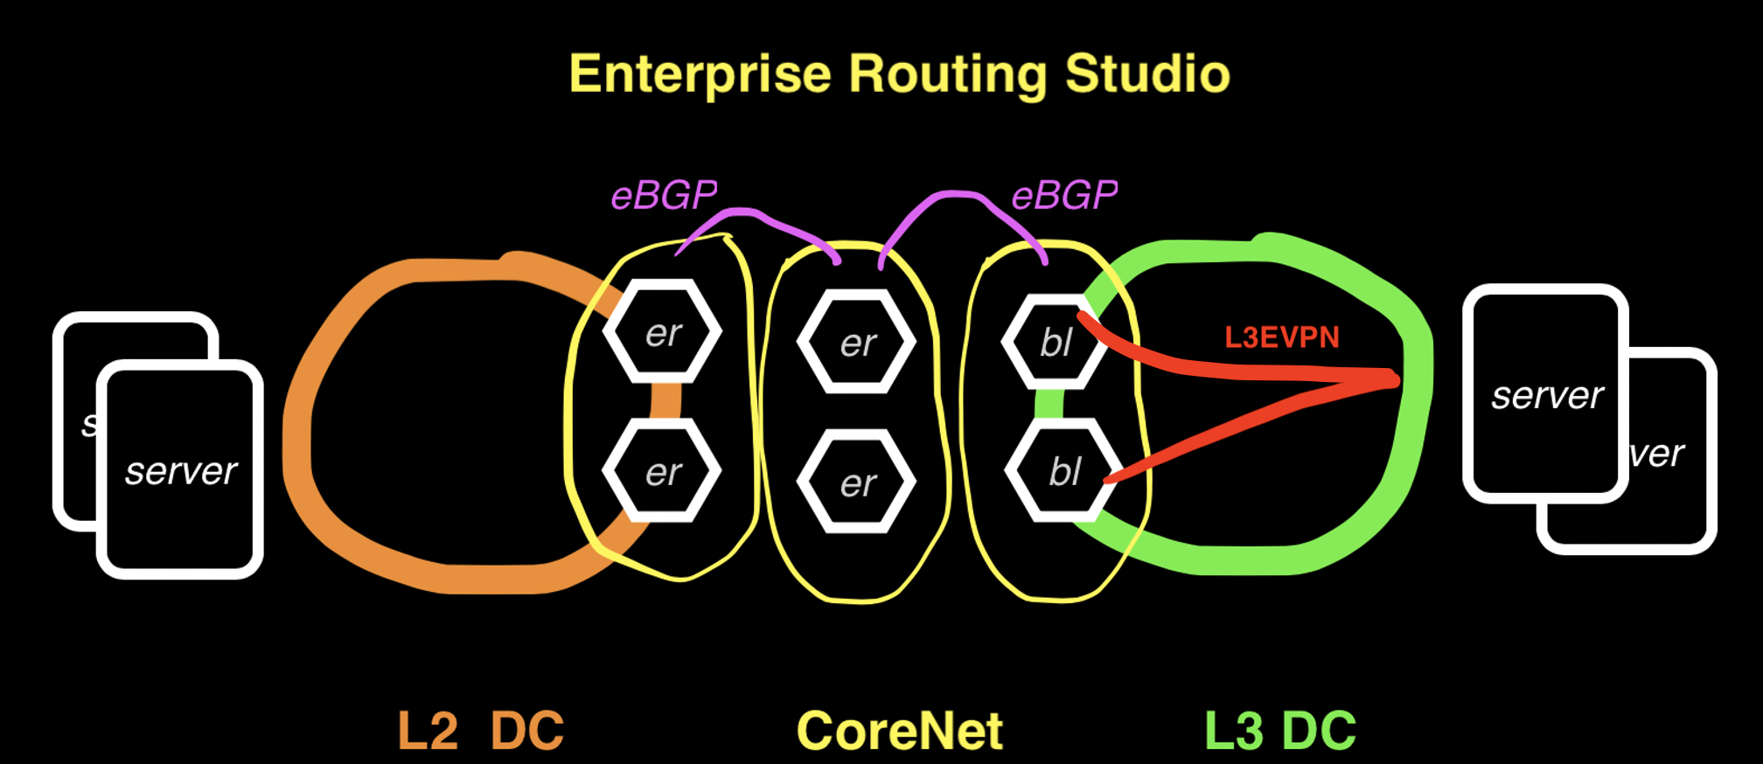

**Topology**



**Features**

* Redundant eBGP in Border Leaf VRF over routed sub-interface
* eBGP on Campus Splines
* VLAN and SVI in Campus Leaf configured in Campus Interfaces Studio
* Management SVI in VRF on L2DC Leaf

**Import**

Enterprise Routing

L3 Leaf Spine

EVPN Studio

Campus Fabric

Campus Interfaces

**Configure**

1. Sanitize the ATD, if necessary
2. Run the tagman.py script for tagsfile-example2.txt
3. Import the Enterprise Routing, Campus Fabric, Campus Interfaces, and L3 Leaf-Spine inputs
4. Set the tag assignment for each studio

|  |  |  |
| --- | --- | --- |
| **Studio** | **Tag Label** | **Tag Value** |
| Enterprise Routing | Network | Ex8-CoreNet-eos1-eos6 |
| L2DC-eos11-eos13 |
| L3DC-Border-Leafs-eos2-eos5 |
| L3DC-End-device-eos9 |
| Campus Fabric | Campus | L2DC-eos11-eos12-eos13 |
| L3DC-End-device-eos9 |
| L3 Leaf-Spine | DC | L3DC-eos2-eos3-eos4-eos5-eos9 |
| Campus Interfaces | device | Eos9 |
| Campus | L2DC-eos11-eos12-eos13 |
| EVPN Studio | device | eos2 |
| eos5 |
| eos9 |

**Deploy**

You’ll now push the configuration you’ve imported to the devices:

1. Review and submit the workspace to Change Control
2. Approve and Execute the change control operation

**Test**

Use the ATD’s configuration screen to access a CLI for the below devices:

* From Campus switch eos12 vrf vlan15 ping DC Leaf eos9 14.14.14.2
* From DC Leaf eos9 14.14.14.2 ping Campus switch eos12 15.15.15.4

## Example Nine: Campus Switch Stacking

**Overview**

In this example we will deploy use Campus Interfaces Studio to configure all switches in each Campus and treat them as a “stack”. VLANs, SVIs, virtual router address, and profile with DHCP Helpers is applied on splines and IP addresses and default route on the cccess switches. The server in the DC is in a L3 EVPN and is reachable by both Campus. From any access switch you should be able to ping the server in the DC.



**Topology**



**Features**

* SVI interface with profiles applied
* DHCP Helper addresses
* VRF configured on SVI

**Import**

Enterprise Routing

Campus Fabric

L3 Leaf-Spine Fabric

EVPN Services

Campus Interfaces

**Configure**

1. Sanitize the ATD, if necessary
2. Run the tagman.py script for tagsfile-example2.txt
3. Import the Enterprise Routing, Campus Fabric, L3 Leaf-Spine, Campus Interfaces, and EVPN Services inputs
4. Set the tag assignment for each studio

|  |  |  |
| --- | --- | --- |
| **Studio** | **Tag Label** | **Tag Value** |
| Enterprise Routing | Network | Ex9-CoreNet-eos1-eos6-eos8-eos11-eos13 |
| Border-Leafs-eos2-eos5 |
| Campus Fabric | Campus | Campus-eos11-eos12-eos13 |
| Campus-eos6-eos8-eos14-eos15-eos18 |
| L3 Leaf-Spine | DC | DC-eos2-eos3-eos4-eos5-eos9 |
| EVPN Services | device | eos2 |
| eos5 |
| eos9 |
| Campus Interfaces | Campus | Campus-eos11-eos12-eos13 |
| Campus-eos6-eos8-eos14-eos15-eos18 |
| device | eos9 |

**Deploy**

You’ll now push the configuration you’ve imported to the devices:

1. Review and submit the workspace to Change Control
2. Approve and Execute the change control operation

**Test**

Use the ATD’s configuration screen to access a CLI for the below devices:

* From Campus1 eos12 ping DC Leaf eos9 14.14.14.2
* From Campus2 eos14 ping DC Leaf eos9 14.14.14.2

## Example Ten: EVPN eTree IPv6 Underlay

**Overview**

In this example you will deploy an OSPFv3 network and connect users to a Core router using L2 EVPN. This is an “L3 to the edge” Campus design and VLANs will be stretched from Access Leafs to a Border Leaf that is connected to a Core Router. OSPFv3 is used to provide both IPv4 and IPv6 routing – loopback0 is an IPv4 address and loopback1 is IPv6 and all links underlay links have both an IPv4 and IPv6 OSPFv3 neighbor. EVPN Etree feature is used in the overlay to restrict users in a vlan to only reach their gateway (the Core Router), and a user on a vlan will not be able to reach each other users on the same vlan. You should be able to ping from the End Devices to its gateway and to the ISPs but pings between the End Devices should fail on EVPN red and gray – yellow is a normal vlan.



**Topology**



**Features**

* EVPN Etree over VXLAN

**Import**

Enterprise Routing

EVPN Services

Campus Interfaces

**Configure**

1. Sanitize the ATD, if necessary
2. Run the tagman.py script for tagsfile-example2.txt
3. Import the Enterprise Routing, Campus Fabric, and Campus Interfaces inputs
4. Set the tag assignment for each studio

|  |  |  |
| --- | --- | --- |
| **Studio** | **Tag Label** | **Tag Value** |
| Enterprise Routing | Network | Ex10-L3Campus-Network |
| ISP-eos15 |
| ISP-eos18 |
| Ex10-Core-Router-oes14 |
| WAN-Router-eos8 |
| EVPN Services | device | eos11 |
| eos1 |
| eos3 |
| eos6 |
| eos4 |
| Campus Interfaces | Network | Ex10-L3Campus-Network |
| Ex10-Core-Router-eos14 |
| device | eos12 |
| eos17 |
| eos7 |
| eos16 |

**Deploy**

You’ll now push the configuration you’ve imported to the devices:

1. Review and submit the workspace to Change Control
2. Approve and Execute the change control operation

**Test**

Use the ATD’s configuration screen to access a CLI for the below devices:

* From End Device eos12 ping Internet route 15.15.15.15 and 18.18.18.18 from inside VRF red
* From End Device eos12 test ETREE, from inside VRF red, eos17 red 3.1.9.17 should not be reachable but gateway 3.1.9.14 should be pingable
* From End Device eos17 ping Internet route 15.15.15.15 and 18.18.18.18 from inside VRF red
* From End Device eos17 test ETREE, from inside VRF red, eos11 red 3.1.9.11 should not be reachable but gateway 3.1.9.14 should be pingable
* From End Device eos17 ping Internet route 15.15.15.15 and 18.18.18.18 from inside VRF yellow
* From End Device eos17 test ETREE, from inside VRF yellow, eos7 yellow 5.0.1.7 should be reachable, same for gateway 5.0.1.14 should be pingable
* From End Device eos7 test ETREE, from inside VRF yellow, eos17 red 5.0.1.17 should be reachable, same for gateway 5.0.1.14 should be pingable
* From End Device eos16 ping Internet route 15.15.15.15 and 18.18.18.18 from inside VRF gray
* From End Device eos16 test ETREE, from inside VRF gey, eos7 gray 3.2.0.7 should not be reachable but gateway 3.2.0.14 should be pingable
* From End Device eos7 ping Internet route 15.15.15.15 and 18.18.18.18 from inside VRF yellow
* End Device eos7 test ETREE, from inside VRF gey, eos16 gray 3.2.0.16 should not be reachable but gateway 3.2.0.14 should be pingable